Dear Parents,

This year we are using the Positive Behavioral Interventions and Supports (PBIS) program again. Dillard Academy is continuing to reach school-wide expectations and expected behaviors. The acronym, SPOT, is the format that was decided to present these expectations. The letters in the acronym stand for Show Respect, Practice Teamwork, Observe Safety, and Take Responsibility.

The students at Dillard Academy have been learning about school-wide behavioral expectations. These expectations have been agreed upon by the staff as an effective way to be proactive in managing behaviors. Each area of our school has their own set of expectations. The information on the back of this letter shows the expectations along with what the particular behaviors should look like at our school in all settings.

This approach to managing behaviors is also a positive one. Students are acknowledged for exhibiting the behaviors that we expect by receiving “PBIS” or “SPOT” DOJO point. At the end of each 9-weeks we are going to have one PBIS party. Every student who achieves the goal of earning the certain number of “PBIS” or “SPOT” DOJO points for that 9-weeks will earn their reward, the PBIS party. The information below goes into detail on the party’s for each 9-weeks.
 | 1st Nine Weeks | 2nd Nine Weeks | 3rd Nine Weeks | 4th Nine Weeks
Number of DOJO Points to Earn: | 24 | 28 | 33 | 33
DOJO Points Due: | September 13, 2019 | December 13, 2019 | March 6, 2020 | May 22, 2020
Date of Party: | September, 24 2019 | December 18, 2019 | March 10, 2020 | K-2: May 28, 2020  3-5: May 27, 2020
Party: | Old School Field Day | Snowflake Shuffle | K-2 Movie 3-5 Outdoor Event | K-2 Water Activity  3-5 Skating
Please take the opportunity to talk to your child about the expectations at school and the importance of continuing to demonstrate Dillard Dalmatian behaviors. With your continued support and involvement, Dillard Academy will remain a school where students can excel. Please look for more PBIS information to come to you throughout the 2019-2020 school year. If you have any questions or concerns, please contact Dillard Academy at (336) 548-2472.

Sincerely,

Your Dillard Dalmations “PBIS” Team

Show Respect, Practice Teamwork, Observe Safety and Take Responsibility!

Schoolwide  Expectations  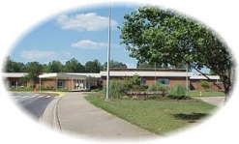 | Hallway 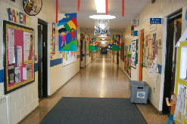 | Cafeteria | Instructional Time  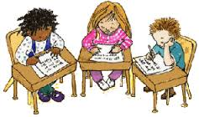 | Restrooms  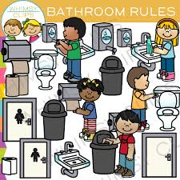 | Playground/Track  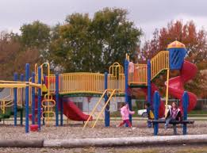 | Buses
Show Respect | - Voice level 0  - Hands to yourself. | - Follow directions  - Voice level 2 | - Be attentive  - Stay in your seat  - Listen to the speaker | - Stalls are private  - Voice level 0 | - Take turns.  - Be aware of others.  - Be kind to others.  - Move carefully. | - Keep hands and feet to yourself.  - Talk with level 1 or 2 voice.  - Follow the bus driver’s directions.
Practice Teamwork | - Be alert and stay with your class  - Walk with a purpose directly to your destination | - Practice good table manners  - Touch only your food; no sharing  - Follow volume levels | - Use kind words  - Help other students  - Set good examples for others to follow | - Keep restroom clean  - Notify an adult of issues | - Share and include others  - Play fairly and safely in designated areas  - Wait your turn  - Do not exclude friends | - Use a quiet voice  - Be ready for your stop  - Be respectful of others and their property
Observe Safety | - Walk on the right side in a single file line  - Face forward | - Walk  - Sit in chairs  - Keep hands, feet and objects to self  - Clean up spills | - Keep hands, feet and objects to self  - Keep class clean  - Use materials safely | - Wash hands with soap and water  - Keep water in the sink  - Keep hands, feet and objects to self | - Stay within boundaries  - Play carefully | - Watch signals  - Follow traffic patterns.
Take Responsibility | - Walk on the right side of the hallway  - Go where you are scheduled | - Clean your area.  - Eat in a timely manner, before you talk.  - Stay in your seat. | - Follow directions.  - Take care of your own work and property. | - Put paper towels in trash can.  - Keep the restroom clean  - Use the restroom in the toilet and flush. | - Keep your hands and feet to yourself  - Walk on mulch. | - Keep all things, including food and drink, in your book bag.  - Sit in your seat on your bottom, facing forward.  - Lights on = level 0.

